pc =

[**pointCloud**](matlab:helpPopup%20pointCloud) with properties:

Location: [1000×3 double]

Count: 1000

XLimits: [-0.1000 1.1000]

YLimits: [-0.1000 2.1000]

ZLimits: [0 8.7496]

Color: []

Normal: []

Intensity: []

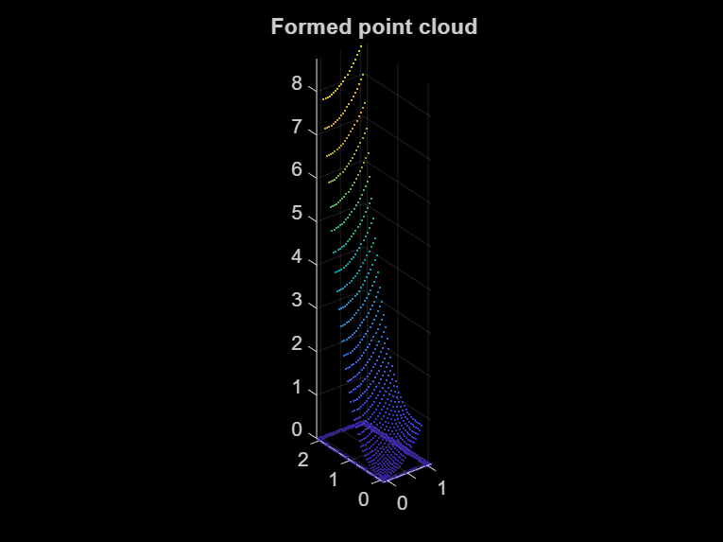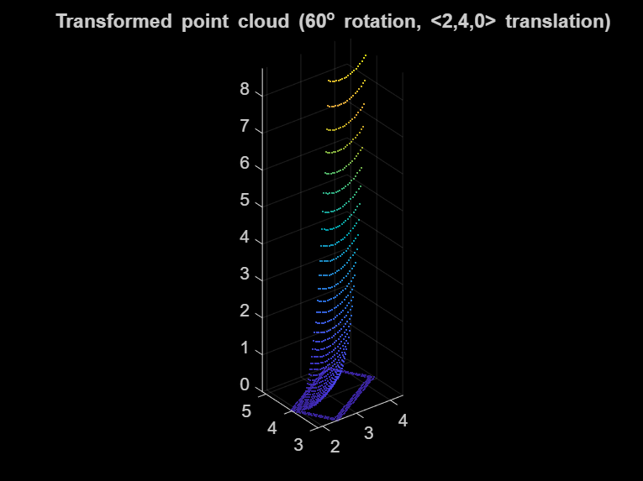

ans = 4×4

0.5000 -0.8660 0 0

0.8660 0.5000 0 0

0 0 1.0000 0

2.0000 4.0000 0 1.0000

ans = 4×4

0.5000 -0.8660 0.0000 0

0.8660 0.5000 0.0000 0

-0.0000 0.0000 1.0000 0

2.0000 4.0000 -0.0000 1.0000